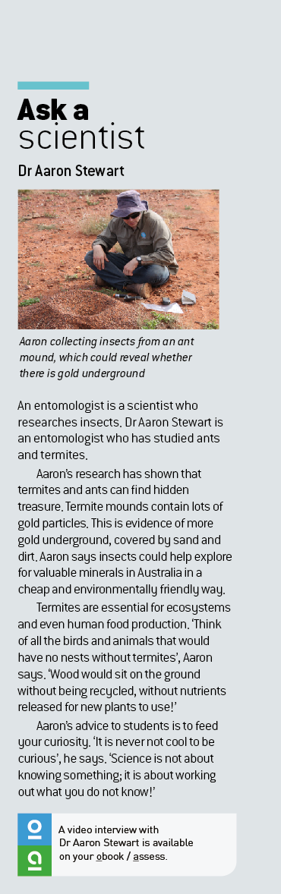Ask a scientist worksheet

1.1 Science is the study of the natural and physical world

Pages 2–3 and 170

Dr Aaron Stewart – entomologist

1 What does an entomologist study?

2 Why are insect mandibles so strong?

3 What is a synchrotron?

4 What do you think it means to ‘publish a scientific paper’? Why would this be important to the scientific community?

5 What does Aaron say that he enjoys about being a scientist?

6 Give three other reasons why you think becoming a scientist might be a good career.

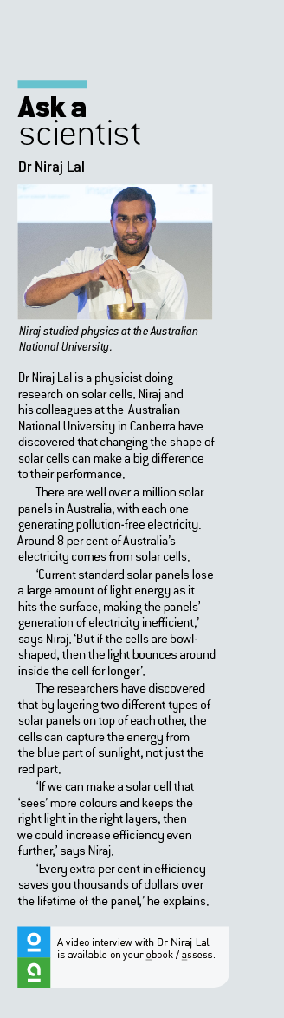Ask a scientist worksheet

1.1 Science is the study of the natural and physical world

Pages 2–3 and 170

Dr Niraj Lal – physicist

1 Construct a mind map below to explore what physics is. Some key words have been provided below to help you.

sound atoms falling rainbow expanding

universe light forces matter

|  |
| --- |
|  |

2 In your own words, summarise what a physicist studies.

3 What are nanomaterials?

4 How efficient are domestic solar panels now? Why is increasing their efficiency so important?

5 Niraj is using a butterfly as inspiration for his solar panels. Can you think of anything else that humans have copied from nature?

Ask a scientist worksheet

1.1 Science is the study of the natural and physical world

Pages 2–3 and 170

Dr Jo Whittaker – geologist

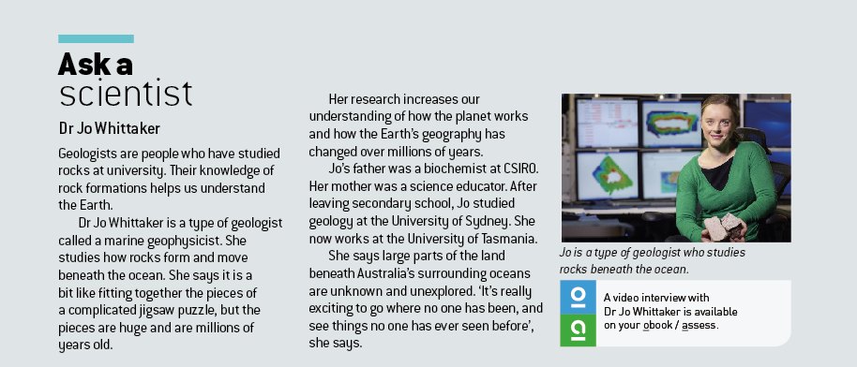

1 What does a geologist study?

2 Jo is a geophysicist. How is this different from a geologist?

3 When asked why the study of geology is important, Jo named three main reasons. Use the table below to record them, rank them by how important you think they are and justify why you have ranked them as you have.

|  |  |  |
| --- | --- | --- |
| Reason | Importance (1–3) | Justification |
|  |  |  |
|  |  |  |
|  |  |  |

4 Name two sources of data that are collected to study the Indian Ocean.

5 In each of the pictures below, label India, Australia and Africa to see how the land masses have changed over time.

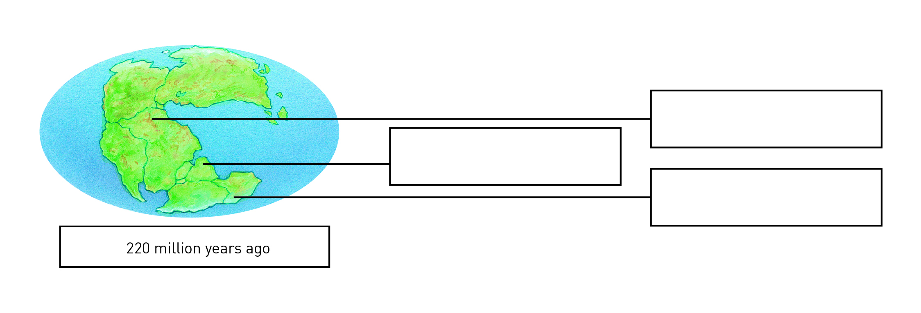

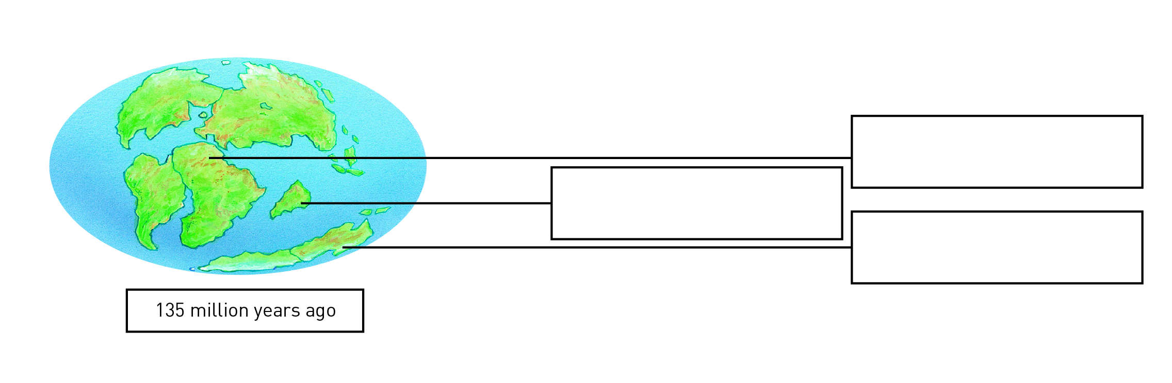

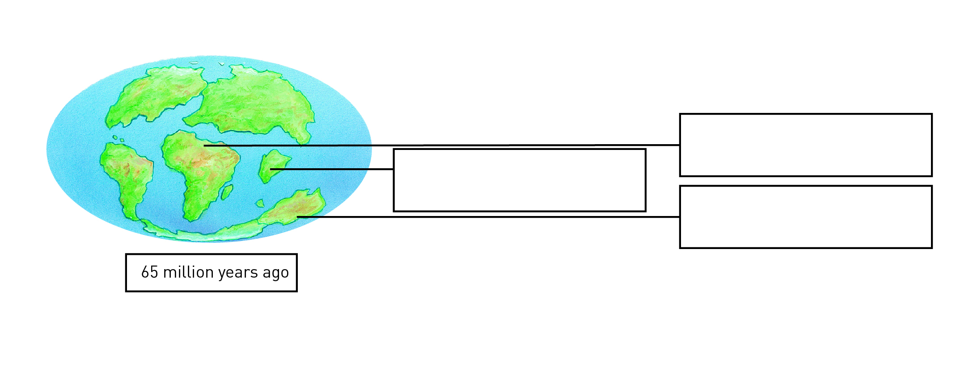

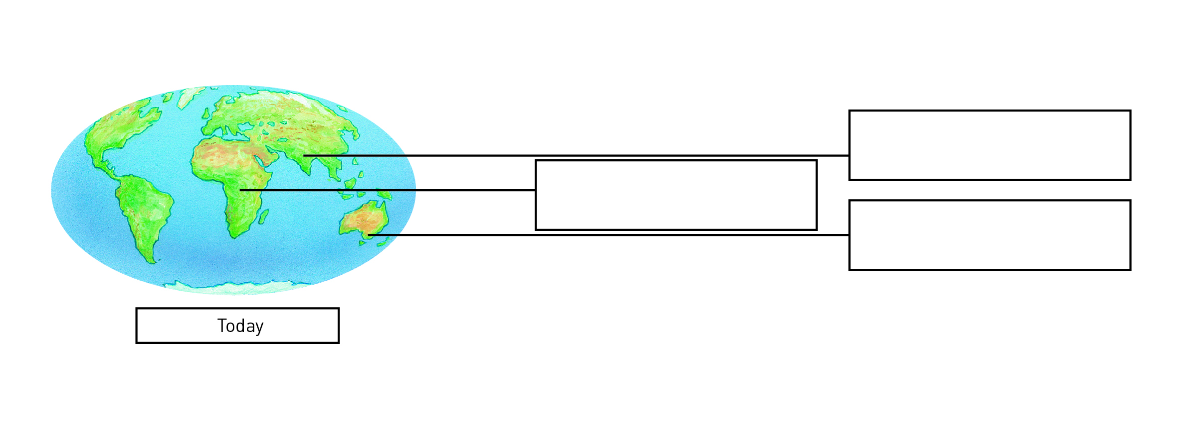

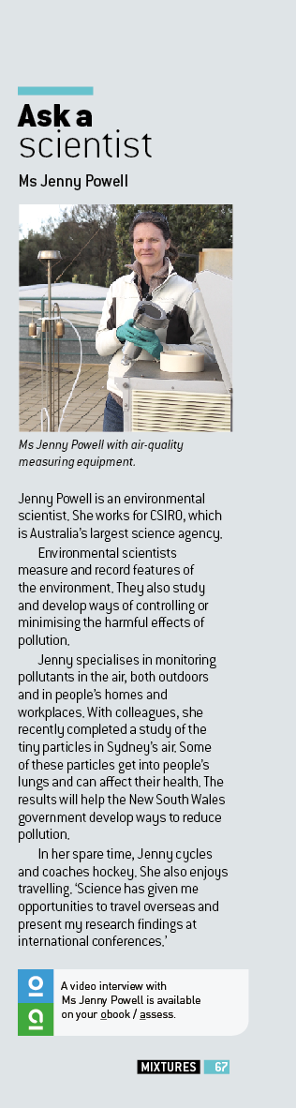Ask a scientist worksheet

1.1 Science is the study of the natural and physical world

Pages 2–3 and 170

Ms Jenny Powell – environmental scientist

1 Jenny is researching POPs in the air. What does POP stand for?

2 What characteristics make POPs persistent?

3 POPs can be a major problem for humans because they enter food chains through the fat of animals we eat. Complete a simple food chain involving **grass**, a **cow**, and a **human**,and briefly explain how POPs affect each level of the food chain.



4 How many carbon atoms and how many oxygen atoms do you think are in CO2?

Carbon:

Oxygen:

5 What are some of the sources of CO2 inside a house that are mentioned in the video?